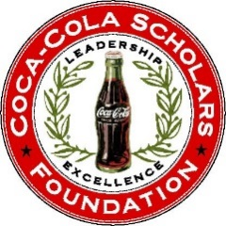**Service Committee Update**

April 11th Conference Call

Sarah, Justin, Micaela, Lindsay

**Update:**

**Scholars on boards**:

* Pulling materials that will give scholars more information about how to be on a board and how to best be connected to other people on similar boards. These materials will eventually be put on the portal for all scholars to access.

**Public Service Video**:

* Conducting interviews that will be compiled together in a short promotional video to encourage scholars to get together and vote. These videos will also give scholars information about being in government and working in public service.

**Service Summit:**

Location: Austin

Dates: September 24-26, 2016

Regional Alumni: Marc Eichenbaum (Houston) and Daron Roberts (UT Austin)

* We have also identified Patrick Daly, Hilary Corna, Maricela Martinez and Mike Woodward as Scholars willing to take part in or help assist in the planning of the event. We have begun constructing the weekend itinerary and creating a budget and are in early stages of indentifying and reaching out to speakers, ideal hotels, and potential sponsors. If you have any questions or suggestions please email me, Thank you!