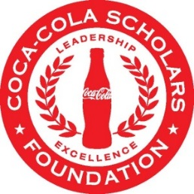

**Standard Alumni Board Committee Meeting Report:**

***Committee: Development Committee***

*Purpose* of meeting:

Discussion on two specific development strategies: Furthering the mass appeal of consistent low dollar donors & Converting the alumni identified through Donor Search in to Leadership donors.

Monday, February 22nd at 2:00 pm

Date of meeting:

This meeting was: ***by phone*** in person

Greg Melia, Deborah Stine, Rudy Fernandez, Megan Harney, Kevin Chung, Jason Pate, Kristen Ward

Alumni Board members on the call/ at the meeting:

* Furthering the mass appeal of consistent low dollar donors through:

1. Birthday messaging linking Scholars’ social media contacts/friends to the CCSF donation link;
2. Messaging around the annual banquet – appeals ranging from $28 one-time, $41/month, $83/month; $500 one-time, to $1000 one-time gifts;
3. Class-based giving.

Agenda Item 1 notes:

***Presenter: ___________________________________***

* Turning the targets identified through Donor Search into Leadership Donors by:

1. Setting and targeting specific goals around the number of Major Donors & Legacy Circle Donors;
2. Mapping candidates by geographic region to align with staff and alumni travel.

Agenda Item 2 notes:

***Presenter: ___________________________________***

Agenda Item 3 notes:

***Presenter: ___________________________________***

A mass appeal was sent to the entire alumni population in conjunction with the 2016 Scholars Weekend and celebration of the 28th class of Scholars. Over $1100 raised to date.

What’s going well?

With Megan’s departure, there is not a staff member dedicated to supporting the committee and the management team. Jane is serving in the interim.

Issues that should be addressed:

Tools/ Resources needed and from whom?

Next Steps (including members responsible for…)?

Fundraising goals have been established to be met by the 2018 Leadership Summit. There will be particular opportunity around Mr. Davis’ retirement at the end of 2018.

Other Comments?

***Date of Next Meeting: ___________________________________­­­­­­­­­­_____________________________***

\****Secretary- don’t forget to send completed notes to your AB Committee Chair, co-chair who oversees your committee and Alumni Manager (Carolyn) within one week of this meeting.***