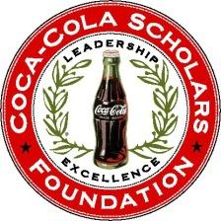

**Alumni Advisory Board**

**Committee Summary & Goals - 2016**

*In preparation for the 2016 AAB Retreat, please use this document to guide you in reflecting on 2016 and in preparation for plans for 2017.*

Committee: Development Meeting Date: 10/19/16

**What worked well in 2016**

1. Given it was a transition year, we identified a really talented group of expert individuals to join the development committee. Deborah and Greg bring great skill sets to the Alumni Board as well.
2. Impact report really well done in 2016, especially in the acknowledgement of donors.
3. Created really strong opportunities for alumni to be engaged which cultivates giving.
4. Practices are being built in to cultivate donors.

**What could be improved**

1. Putting the plan into action – identifying all of the targets for various levels of giving.
2. Would like to see real tangible outcomes from the planning.
3. Strategy for cultivating and raising donors to higher level.

**What will your top 3 action items by for 2017?**

1. _____________________________________________________________________
2. _____________________________________________________________________
3. _____________________________________________________________________

Submitted by: Jane Hopkins