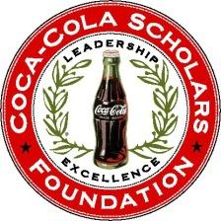

**Alumni Advisory Board**

**Committee Summary & Goals - 2016**

*In preparation for the 2016 AAB Retreat, please use this document to guide you in reflecting on 2016 and in preparation for plans for 2017.*

Committee: __Career/Leadership Development Meeting Date: ____10/11/16_____

**What worked well in 2016**

1. Continued successful Coke Scholars Pro networking events (Google, Twitter) with good programming, turnout and venues. One more planned for 2016.
2. Successful pilot of family-friendly event (picnic) in Atlanta.
3. _____________________________________________________________________

**What could be improved**

1. Need to diversify geographic scope of mixer events.
2. Need to get different target audiences (consider govt. or non-profits).
3. Need to innovate and come up with different ideas.

**What will your top 3 action items by for 2017?**

1. Work on venture capital / start up based program
2. Locate hosts for DC event re # 2 above.
3. Support Staff efforts around education on networking (tips, etc.)

Submitted by: _Kevin Chung